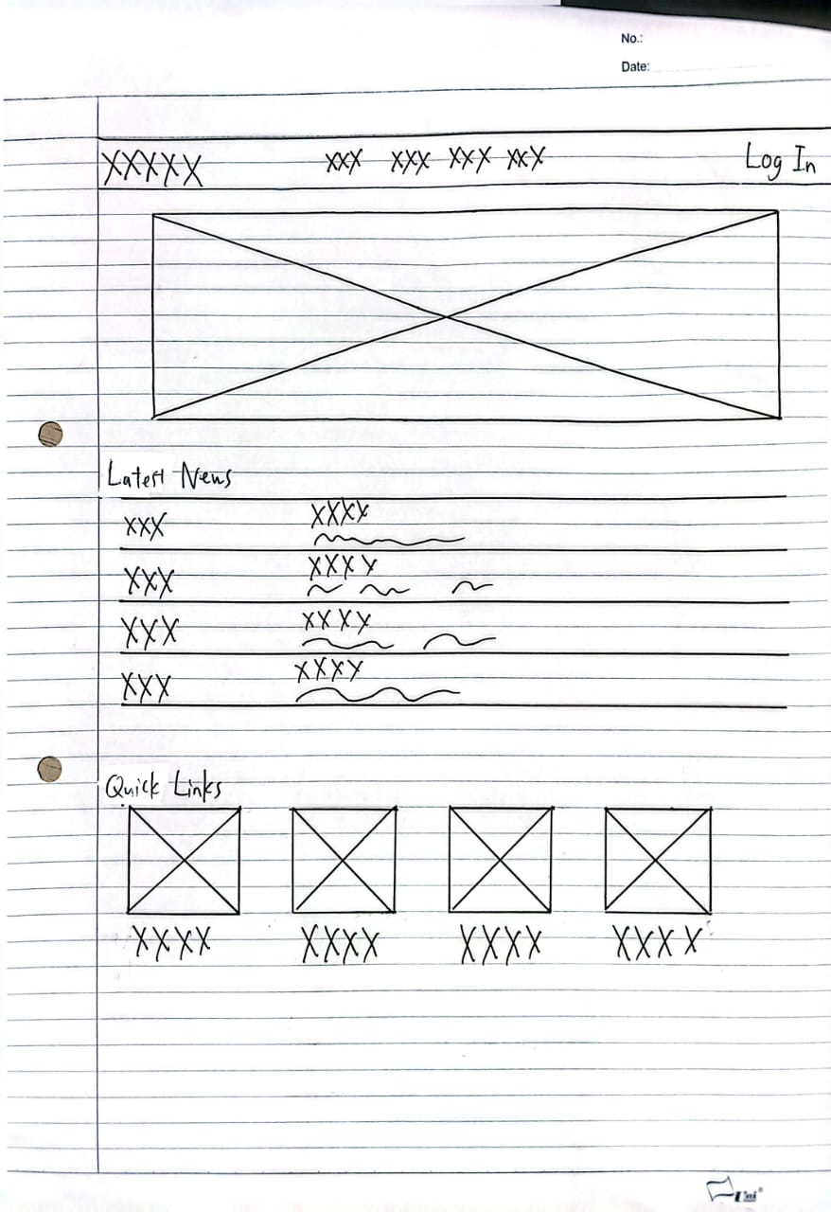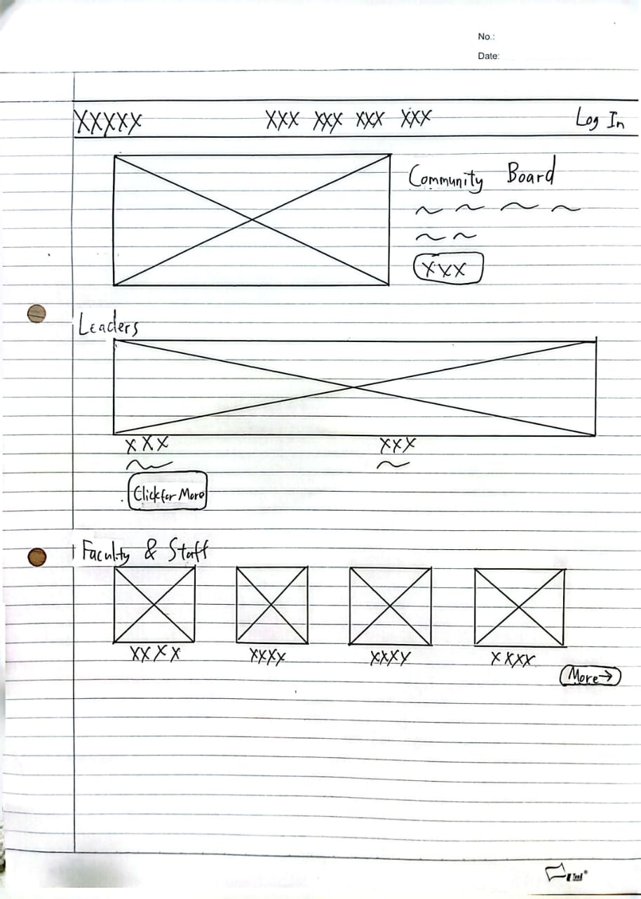
Usability Goal | Design Guidelines | Justification
Learnability | Fitts’s Law  Target Size | On the Community page, the click for more and More buttons are to be displayed as large and differentiated buttons. It is easier to move the cursor and to use the click and minimizes errors at the first contact of new users with the staff directory.
 | Visual Hierarchy | The text scale of the "Latest News" is descending. The news is written with large bold fonts and wavy lines are used to write the summary, which allows a clear reading path. The page is skimmable since the user gets to learn to go through the large text to determine whether or not they want to get the details.
 | Jakob Nielson  Consistency | Positioning the “Latest News” title and a photo about Yale follows the conventions of a web. This is compliant with the other sites of the school, the student acquires the structure immediately because it is already consistent with his or her already formed assumptions of a general introduction to the school.
 | Gestalt Principles  Proximity | The image, the text summary, and the XXXX button are positioned very closely in the section of the community board. This forms a good visual connection and therefore, the user is aware that the three elements are components of a particular post which does not require a border.
Memorability | Don Norman  Consistency | Whether it is Quick Links or Faculty and Staff, the grid is the same - 4-column grid. The section creates a map in the mind of the user which becomes more memorable where the information is stored by them next time they revisit.
 | Jakob Nielson  Recognition over Recall | Quick Links section is composed of icons and labels of the most visited pages. The user does not have to remember the menu path in his/her memory, but merely recognizes the visual block that he/she requires, which is a lot quicker.
 | Feedback Loop | The XXX positioning and Click For More buttons are used as clear indicators of the position of the user in the process. The system gives immediate feedback by displaying what is what can be clicked or filled. This causes the interaction to stick since the user does not have to guess whether the taking of action was successful or not; s/he has the immediate response.
 | George Miller  Chunking | The Quick Links allows a complex navigation to be simplified into simple blocks. One can simplify these shortcuts into small equal squares by a function called chunking which means that instead of remembering the long, convoluted dropdown menu, the user merely remembers a row of icons.

